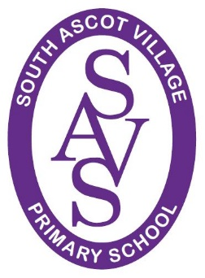
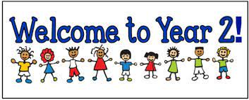

Dear Parents/Carers

A big welcome back to school and into Year 2. We really hope that you have had a restful and enjoyable summer holiday! We are looking forward to teaching your child this year and thought we would just let you know a little bit about our routines and what’s happening in the coming year in Year 2!

Daily routines and expectations

- Your child will be expected to have a pair of outside shoes that are quick and easy to put on, that will also be doubled up as their PE shoes. No laces unless they are able to do them independently. They have the pleasure of playing on the field and in the woods. Allowing them to have a pair of outside shoes saves their smarter school shoes! These will stay in school every day.
- PLEASE ENSURE THAT EVERYTHING IS LABELLED. Labelled clothes find their way back .
- Their PE days will be Tuesday and Thursday. They will need to come into school already changed for PE on those days. PE kit is School house colour T-shirt and plain black short/tracksuit bottoms.
- Their Forest School time will be Friday afternoon. There will be a separate letter for this.
- Every child needs to bring in a water bottle daily with water in it.
- Please ensure your child has a book bag rather than a large ruck sack that largely remains empty!
- Healthy snacks: The school provides free fruit and vegetables daily. If you wish to send in a snack then that is fine, but it has to be healthy. NO sweets, crisps, chocolate, biscuits etc.
- Your child should have received their reading record book. We actively encourage your child to read daily for 10 minutes at least. Research shows that this is essential in order for your child to progress at a successful rate and to develop a real love of reading. There will be a ‘book bag book’ linked to phonics and a book to share with your child. As the term continues, we will be sending home some key words for them to learn to read, but we will send a separate letter informing you about this nearer the time. We will expect the reading record to be signed by a parent/carer each time your child has read.
- Every day we will be doing phonics with your child, and we will also be sending this home to reinforce their learning.

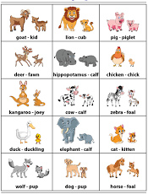
Our topics this term

This term our topic is My World

We will kick start this topic in Geography looking at our local area and mapping skills. We will learn about physical and human features and practise identifying them in our local area as well as different locations through researching on the computers and pictures of places. We will learn to make our own maps and understand the importance of clear symbols. This will link with our English lessons, where we will look at mapping out stories and describing settings. The children will assess our grounds and see how we can improve them (i.e. litter picking).

In Art we will be practising our sketching skills and doing observational drawings of our local nature and animals. We will look at using different media to create art.

Animals including humans will be our first science topic, where we will be identifying that animals, including humans, have offspring which grow into adults. We will also find out about and describe the basic needs of animals, including humans, for survival (water, food and air). Finally, we will describe the importance for humans of exercise, eating the right amounts of different types of food, and hygiene.

Music lessons will be related to the topic throughout the term, where they will learn to sing, listen to music and talk about different instruments they can hear and recognise. Children will then have the opportunity to play various percussion instruments and repeat short melodies.

Design and technology will involve using textiles to make an animal of their choice.

They will learn about friendships and families and how families are different. We will also look at being healthy that mirrors our learning we will do in Science.

PE will involve invasion games such as rugby and multi skills to build the basic skills needed for sport.
In Re we will be looking at leadership and religious symbols and how they differ between Christianity and Judaism. Throughout the term computing will be taught, starting with online safety, spreadsheets to collate data and creating pictures.

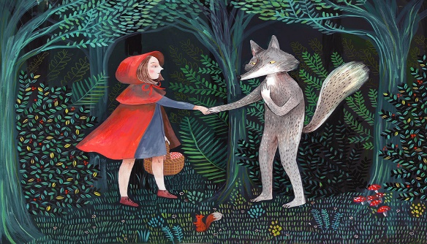
In Literacy we will look at traditional stories and looking at character descriptions and story settings. Non-fiction texts about animals and humans will be shared and read to aid our Science topic, as well as animal poems We will write our own stories and poems. We will do phonics daily and group reading.

In Maths we will be looking at number facts and place value to gain a good understanding of number. We will look at more and less of a given number, counting on and back. We will continue to count in 2’s, 5’s and 10’s and will look at 2D and 3D shape, length and weight.

I will keep you updated over the term with homework, reading, Reading Eggs etc. In the meantime, I would like to say that I am always happy to chat to you about your child and that I very much have an open-door policy. Obviously, sometimes are harder to chat than others, but please feel free to approach me when it’s appropriate and I endeavour to speak to you as soon as possible. Keep an eye on the door as I will post reminders up there as well!

I look forward to working with you and your children in their new adventure in Year 2!

Kind regards

Mrs Grumbt

