Year 5 Newsletter
September 2022

Welcome to Year 5

I hope you have had a lovely summer and are ready for new, exciting challenges this year. Reading records will be issued and checked in school daily. Comments and evidence of reading should be recorded in the diary (x4 a week minimum). Parental support with reading remains invaluable, whilst many of the children read fluently; discussing a book helps to develop comprehension skills. Please make the most of your reading eggs account www.readingeggs.com/login. We will be attempting to be going paperless, Homework will be issued online via Microsoft Teams on a Thursday to be handed in
Much of our work this term is linked to the theme Earth and Space.

Literacy  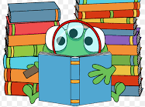 | We will be reading non-fiction texts around the theme of Earth and Space. Literacy activities include story planning, writing setting description and character profiles. Differentiated spelling lists will be available online on a Friday to be tested the following week.  The children will be encouraged to structure their writing using paragraphs and linking ideas across paragraphs. Punctuating their work with commas and brackets to add extra information.
We will continue to develop the children’s understanding of written methods for addition, subtraction, multiplication and division. Having a quick recall of times tables facts aids calculation so please keep practising at home. In addition, practising telling the time on an analogue clock would be very useful. Do take the opportunity to apply your maths skills in real life contexts e.g. calculating change whilst out shopping and weighing ingredients to follow a recipe.  This year we start work on percentages in relation to fractions and decimals. We will also be learning to measure angles using a protractor. |  | 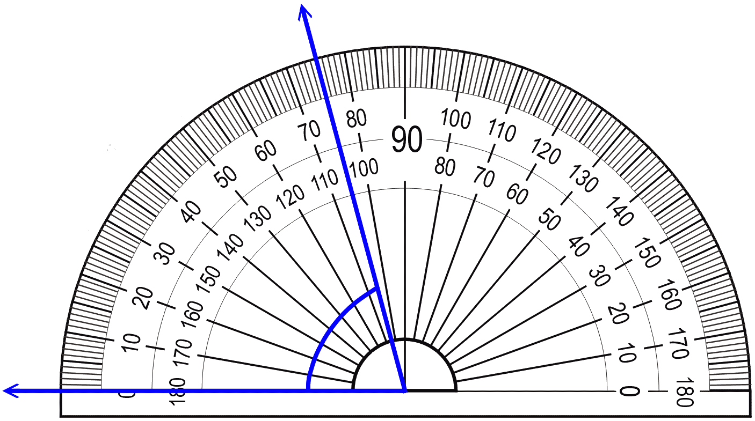  Numeracy
Science | This term in Science we will be exploring Earth and Space. Finding out about the solar system, moon and shadows. After half term we will be finding out more about forces. There is lots of opportunity for planning practical investigations and presenting findings.
Information and Communication Technology | In Computing we will reinforcing the importance of E-safety, making them conscious of their digital footprint and how to stay safe online as well as developing the children’s coding skills.
Religious Education | In RE the children will be developing their understanding of the Sikh faith. Finding out about Gurus. The Sikh Holy book is called the Guru Granth Sahib,
Physical Education | This half term the children will play tag rugby and hockey. Please ensure a pair of ‘field shoes’ remain in school at all times. As the weather gets colder, suitable clothing e.g. a tracksuit is required. | This term Year 5 have PE on a Wednesday morning and Friday afternoon. Children are to attend school wearing their PE kits on these days.
Topic (Art,Geography,History,DesignTechnology) | In History, we will be finding out about life during the Anglo-Saxon period exploring the settlements culture, food, farming, law and justice. In Art and DT we will attempt to recreate some Anglo Saxon artefacts. In geography, we will be developing our map fieldwork skills. Looking at Atlases, grid references and planning routes.
Modern Foreign Language | The children will continue to learn Spanish this year. Listening, speaking and reading phrases.

We are lucky enough to have Mrs Kidd working with us in the morning as a teaching assistant.
If you have any queries or concerns, please do not hesitate to contact me.
It’s great to have this class again, I look forward to working with you all over the year.

Miss Webb

